Design Phase

Brainstorm & Idea Prioritization Template
Date | 13 July 2026
Team ID | SWTID-2026-8803
Project Name | Book Doctor Management System
Maximum Marks | 4 Marks

Brainstorming provides a free and open environment that encourages everyone within the team to participate in the creative thinking process that leads to problem solving. Prioritizing volume over value, out-of-the-box ideas are welcomed and built upon, and all participants collaborate to develop a rich set of solutions for the Book Doctor Management System.

Step-1: Team Gathering, Collaboration and Select the Problem Statement
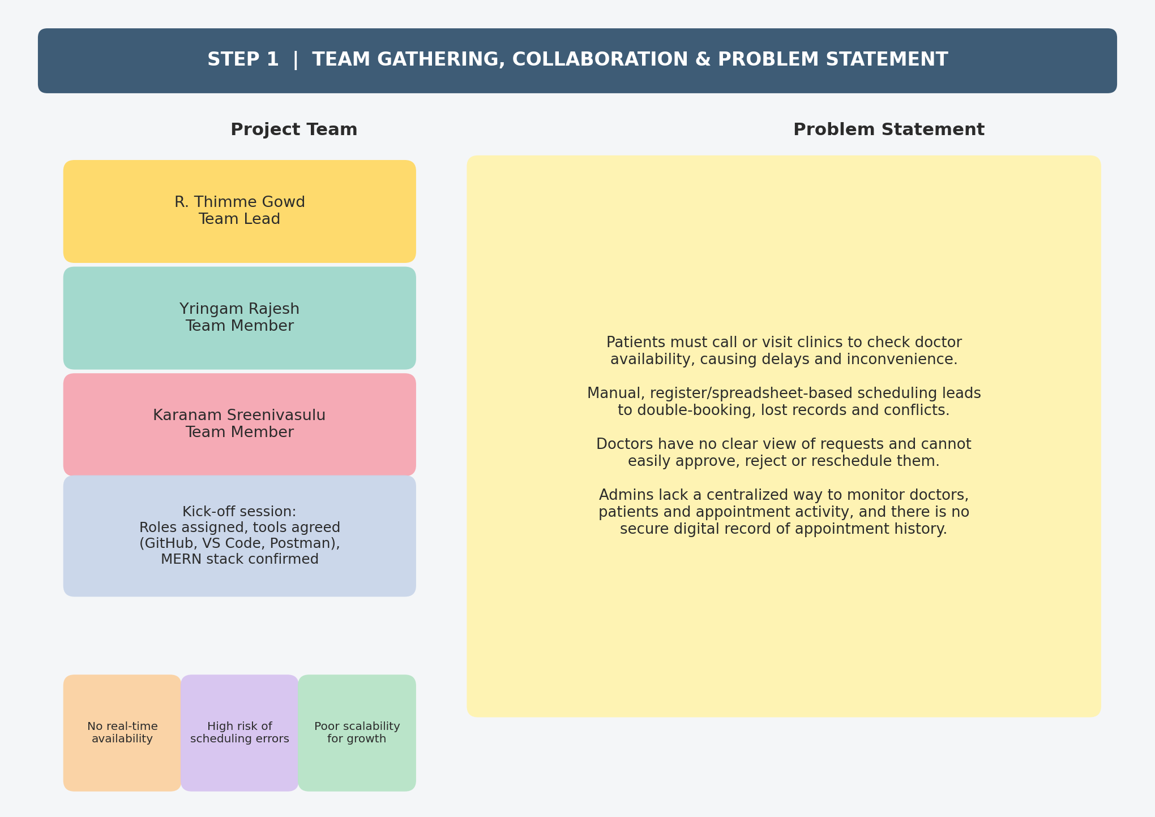

Step-2: Brainstorm, Idea Listing and Grouping
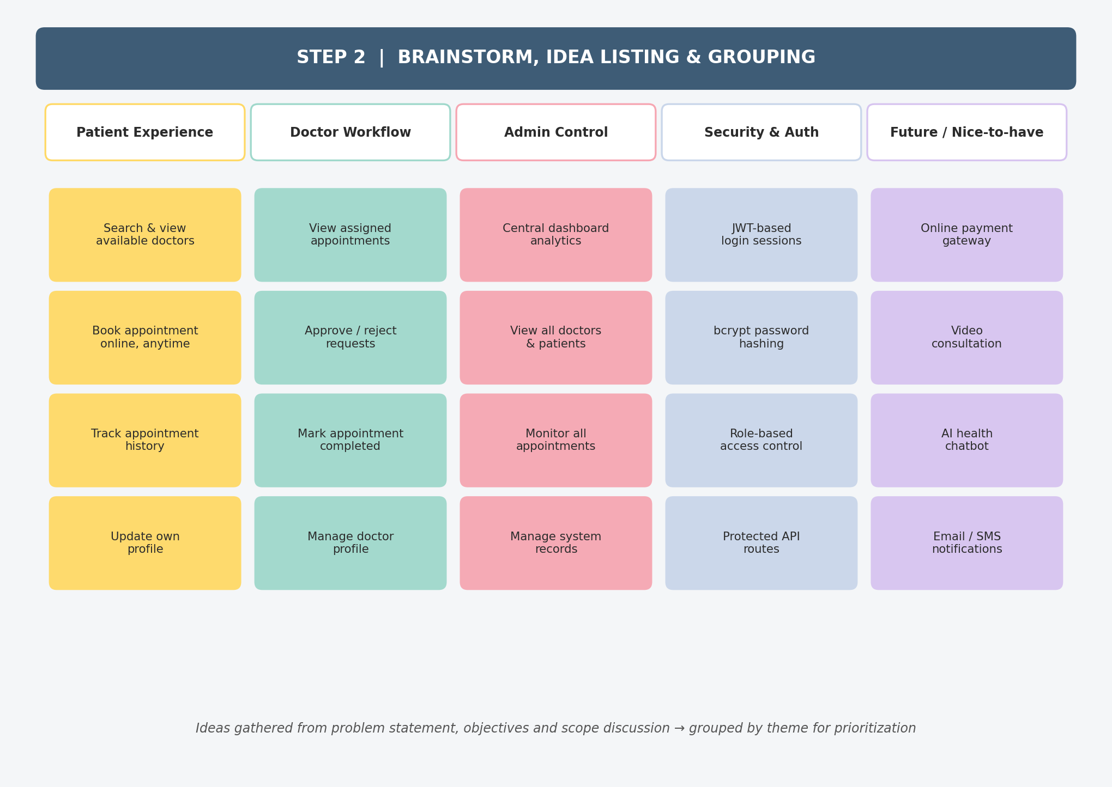

Step-3: Idea Prioritization
